Navigate to the Horse Sport Ireland website
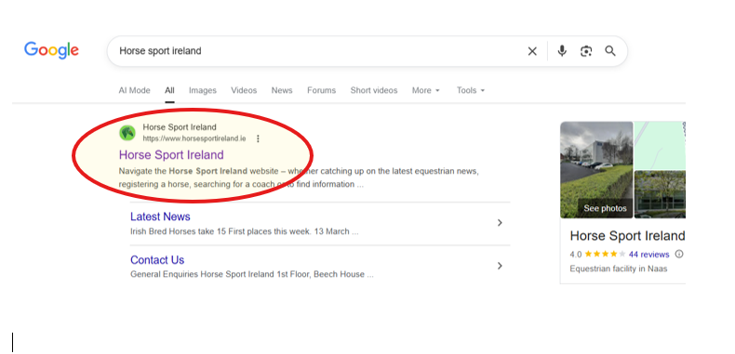
Then click the option Governance at the top of the page
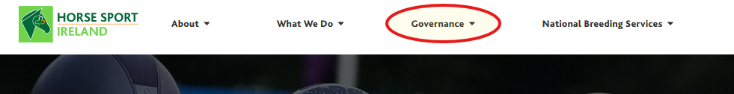
Then when the dropdown appears please select Vetting (Garda/Access NI)
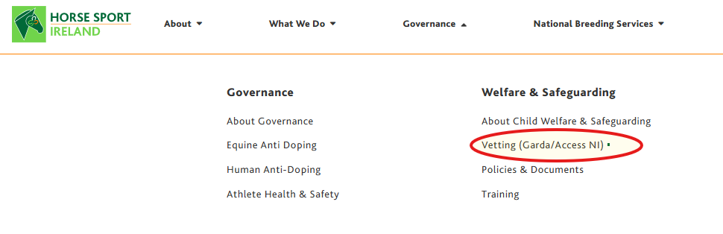

When the next page appears please scroll down to the bottom of the page and select HSI Access NI payment page

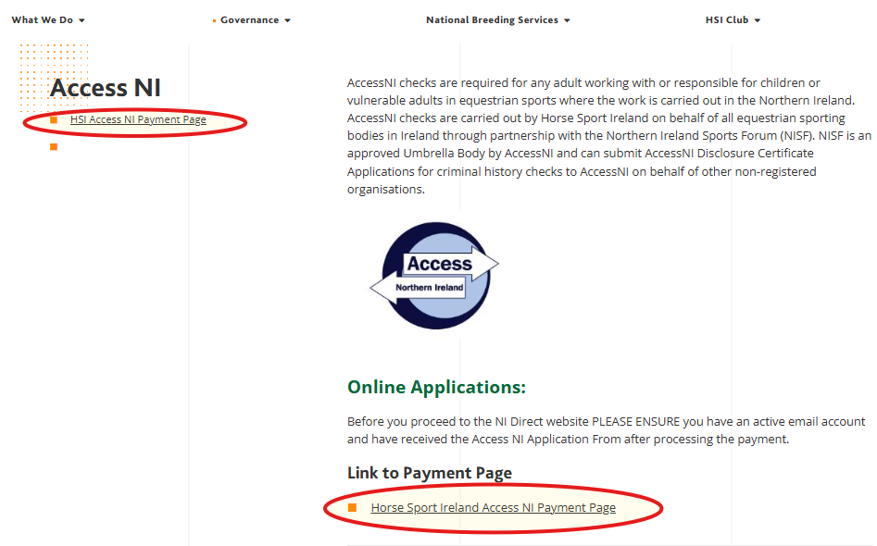

You will then be given the following page
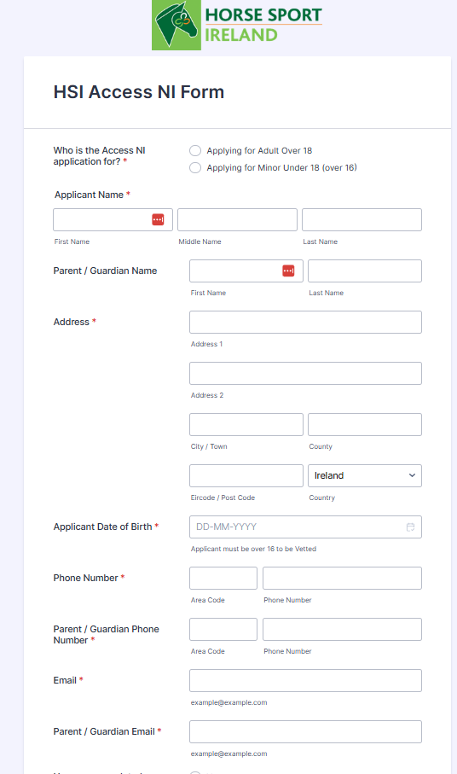
Please fill in the above page with all your details and then fill in the payment option at the bottom of the page.

You will then receive the following message if your payment has been processed.
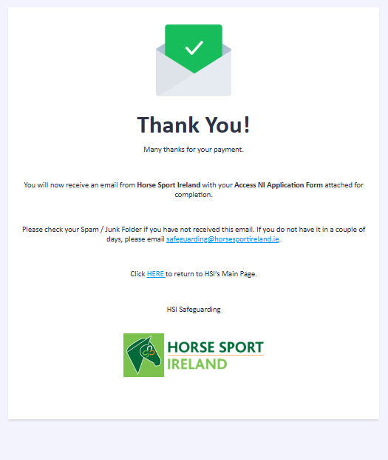
You should then receive the following mail from Horse Sport Ireland.

Dear [ XXXXXXXXX ]
Thank you for your payment. Please see attached the Horse Sport Ireland Access NI Application Form. Please print off the attached form and sign and date as required on page 1. The information you submitted on the form is pre-populated on attached document for your convenience.
You are also required to follow the instructions as noted on Page 2 and complete the online portion of the application process. This will include an ID Verification process directly with Access NI.
You are required to complete the details on the top section on Page 3 once the online portion is completed. A unique 10-digit reference number will be assigned to your application, please note that here. Please tick the box to confirm that the application can progress.
The remaining information on Page 3 will be completed by HSI. The list of ID accepted by Access NI is listed on Page 4.
Completed forms and relevant copies of ID can be sent to HSI Vetting Liaison Person, Horse Sport Ireland. 1st Floor, Beech House, Millennium Park, Naas, Co. Kildare, W91TK7N.
Once your application is completed a Disclosure Report will be issued to you directly. This will need to be shared with HSI Safeguarding by email to safeguarding@horsesportireland.ie. This report is NOT confirmation of Access NI clearance with HSI. A review of the report will be carried out by HSI before confirmation is issued by email by them.
Should you have any issues please contact us by email at safeguarding@horsesportireland.ie.
Kind regards,
Safeguarding Department
Horse Sport Ireland

Enclosed in the email will be 2 documents
- Receipt of payment for Access NI Vetting via HSI
- Set of instructions from HSI to log in to Access NI

Next step is to go to the Access NI link
Click the link below and scroll to the end of this page
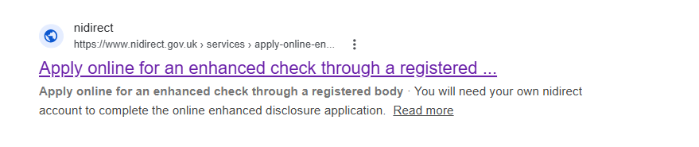
Then click apply for Access NI Enhanced check
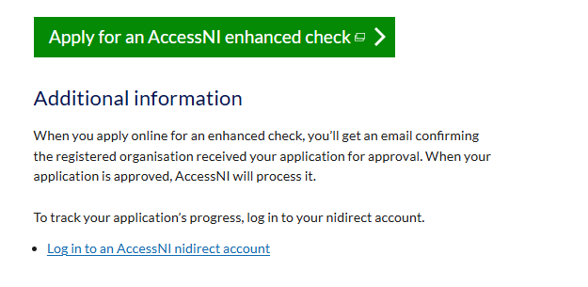
This will bring you to the NIDirect Login page.

Here you will use your previously save login details for Access NI or you will create a new login by clicking Create account beside the Sign in button.
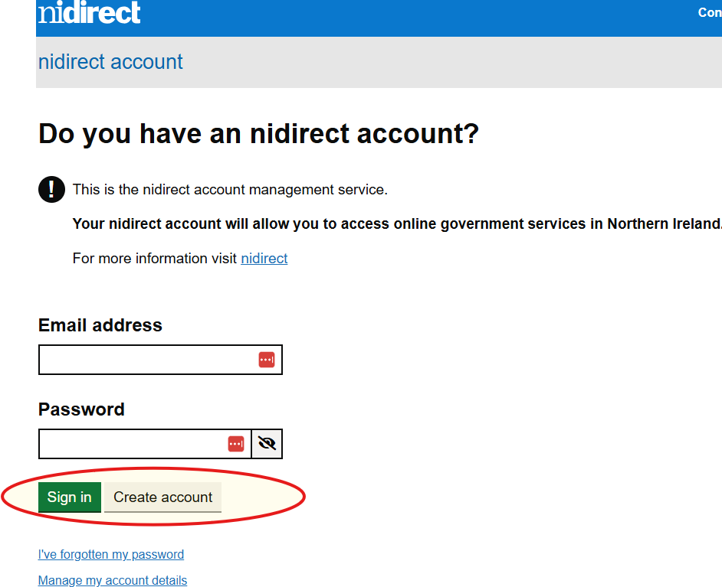
You will get the next page
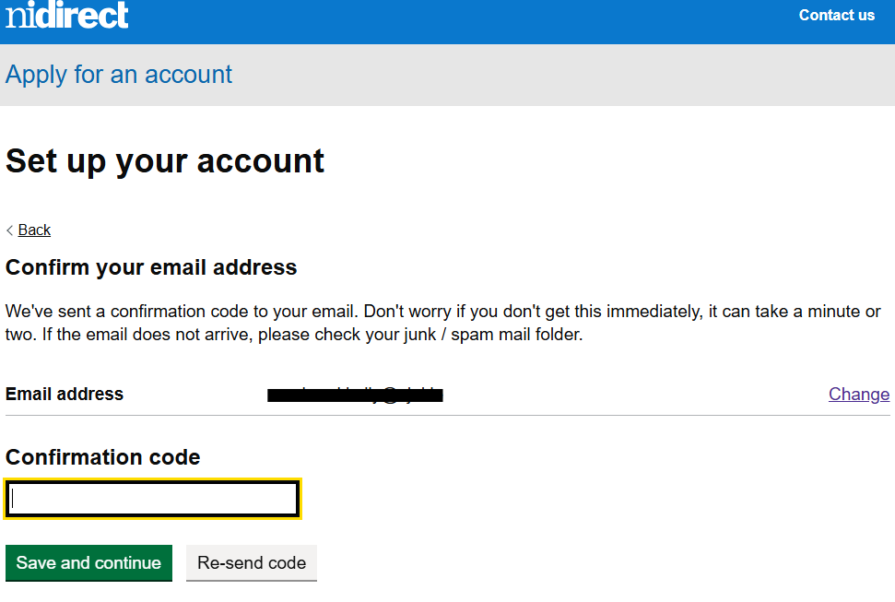
Go to your email address and copy the code you have been send and enter it, then press save and continue.

Fill in the following page
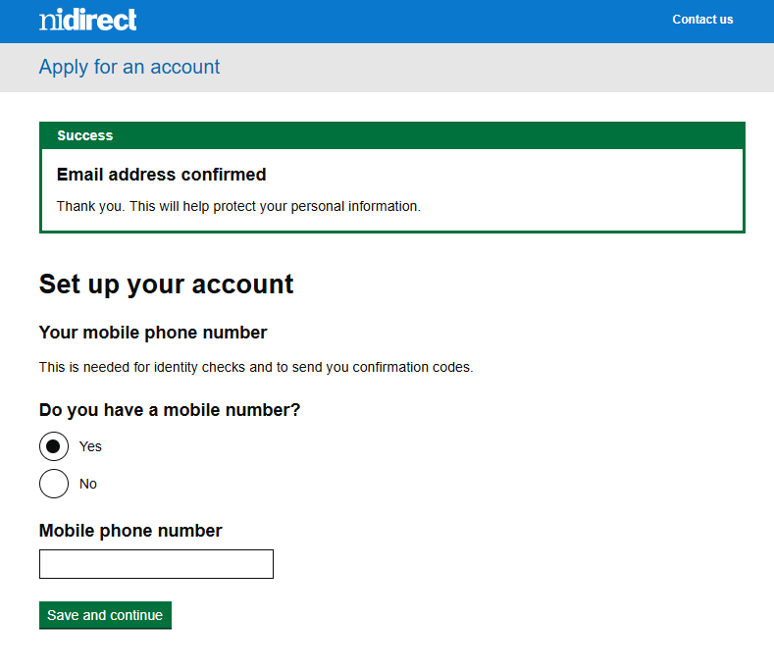
Key in your mobile number and then get your code from email and key that in.
You will then be asked a further question about how to secure your account please select the appropriate option for you.
The next screen will be to create a passport for Access NI
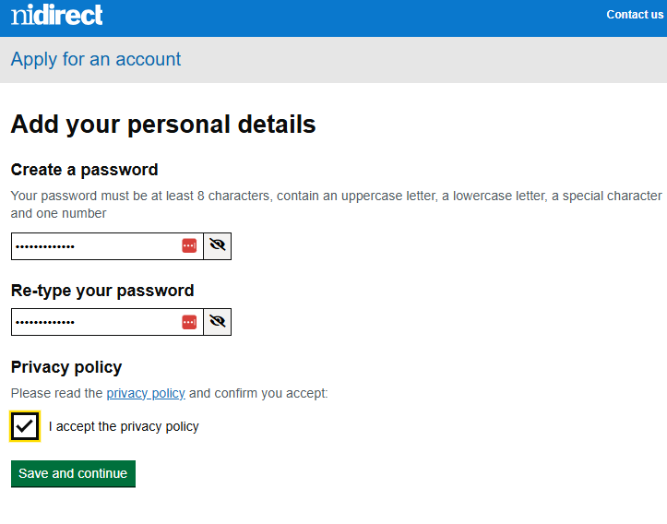
Then fill in the next page with will be your Personal Details, then the next page will be to fill in your address.
Check the details and confirm if they are correct on the next page.
Next is Identity Verification
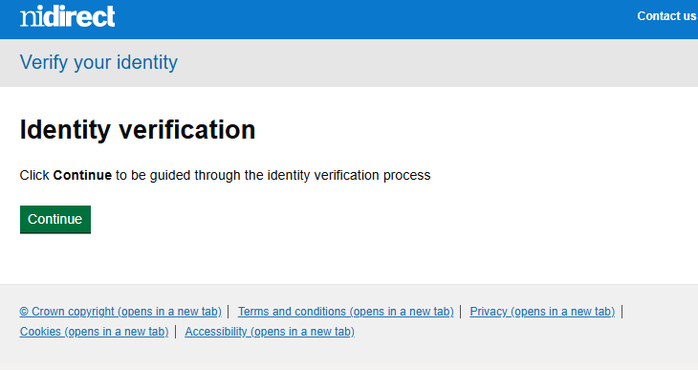
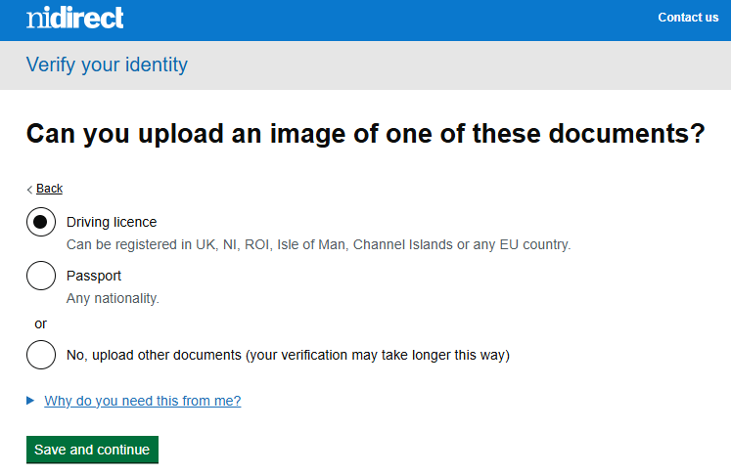
There may be additional image verification so you might need to take a photograph of yourself and upload it.
So applications will require no manual verification and some will be verified automatically.

You will then be located your reference number which is valid for 5 days.
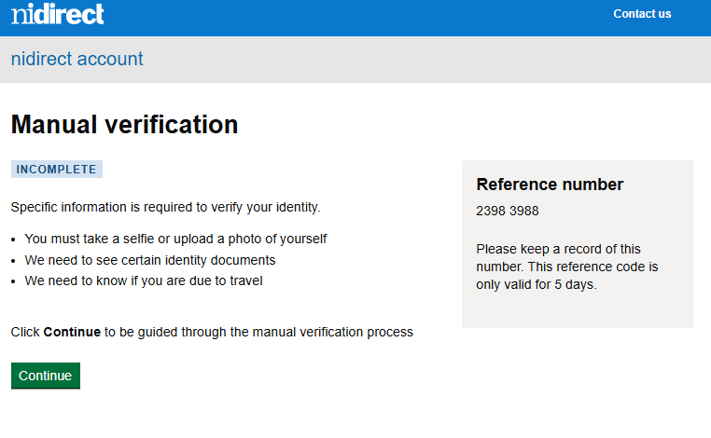
You will be asked to upload additional documents here please upload as appropriate.
Then once these are uploaded you will get the following message
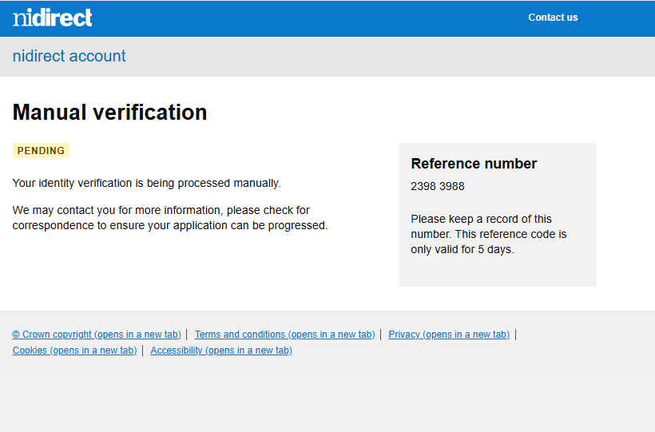
Your request for Vetting is now completed.

When you are finished with the digital part of the application please return to these pages filled in and send them to Safeguarding in Horse Sport Ireland.
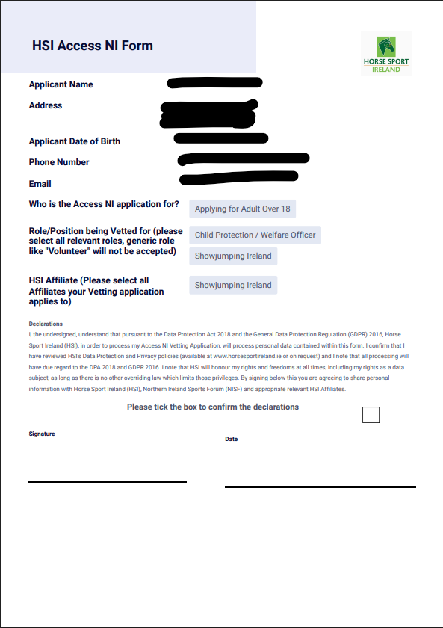
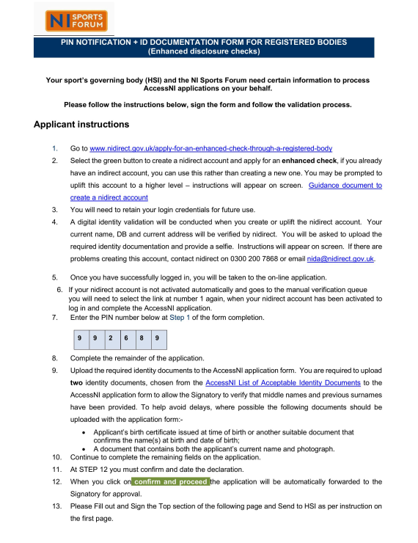

At the end of the digital application you will receive the code to go in below please ensure you take note of all codes that show up on the screen.
This will be emailed to you after all the ID documents have been loaded and approved by Access NI.
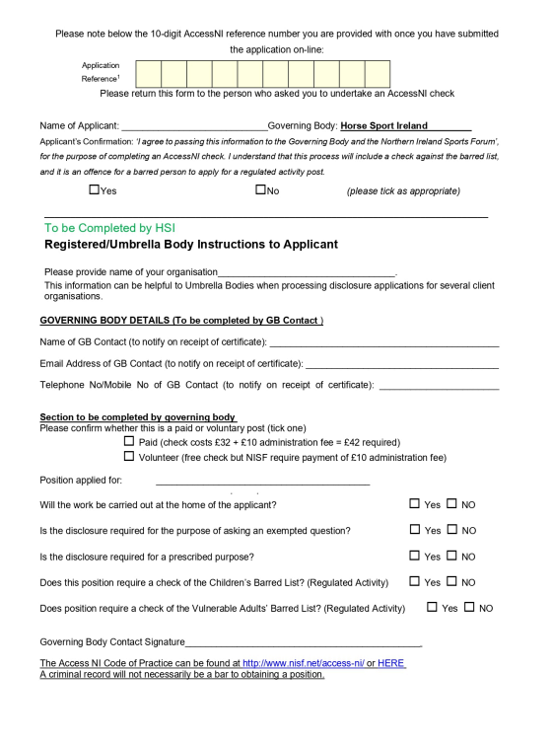
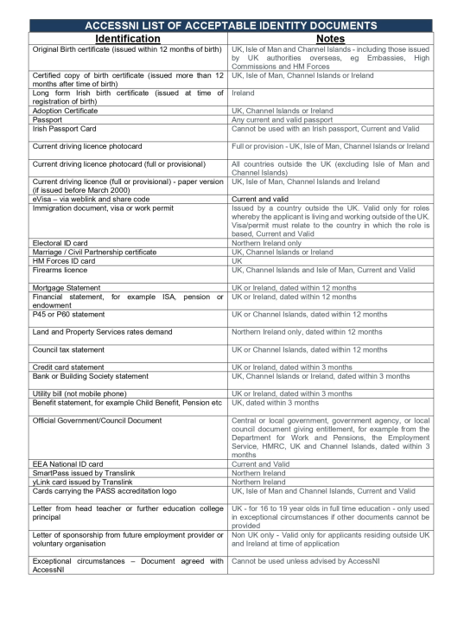
You will then be provide with you 10 digit code once all the correct information is uploaded.

